**Scrubs Essay Portal Test:**

16 – 05 – 2025

# Functionality:

## Func_01:

Upload file(s) issue.

**Description:**

1. Initiate an order.
2. When navigated to the upload file(s) section.
3. Upload one or more files(s).
4. Delete the uploaded file(s).
5. Now, try uploading the same file(s).

These same file(s) cannot be uploaded.

## Func_02:

There is no notification received for the “Pay Remaining” transaction of the order placed through “Partial Payment.

## Func_03:

Notification navigates to the crashed Page.

1. Click the notification icon, and the notification window appears.
2. Now, click the “See all notifications” button, and it redirects to the notifications page.
3. Click, any of the successful order notifications.
4. It redirects to the crashed page.

## Func_04:

Deadline sustainability issue, when navigating back and forth through the pages.

1. Initiate an order.
2. Select either of the two deadline categories, “Less than 12 hours” or “12 – 24 hours”.
3. Select any of the respective deadline hours.
4. Proceed to the Stripe transaction page.
5. Now, navigate back to the deadline selection page.

**Notice that the selected deadline is displayed correctly in the order summary, but the selected hours are not sustained in the “deadline hours” field.**

# DEADLINE ISSUES: (Time and region changed to Canada)

## Func_01

1. Select **“Less than 12 hours”,** deadline category.
2. Further, select “12 hours”.
3. Go for partial payment.
4. The deadline is incorrect in the section mentioned below.
   1. Deadline selection page.

**The issue persists with every deadline available in the “Less than 12 hours” category.**

## Func_02

1. Select **“12-24 hours”,** deadline category.
2. Further, select “24 hours”.
3. Choose either of the payment methods.
4. The deadline is incorrect and inconsistent in the sections mentioned below.
   1. Deadline selection page.
   2. Order success page.
   3. Order details in “In Progress”, page.
   4. “Order Successful” email received by the user.

**The issue persists for all of the deadline selections in the respective category.**

# UI / UX

## ID: UI_01

**Steps to Reproduce:**

1. **Navigate to the login page.**
2. **Fill in an unregistered email.**
3. **The toast with a message appears, “The password field is required”.**
4. The check should be for the email first; once the email is verified, it should check the password field.

**Screenshot:**

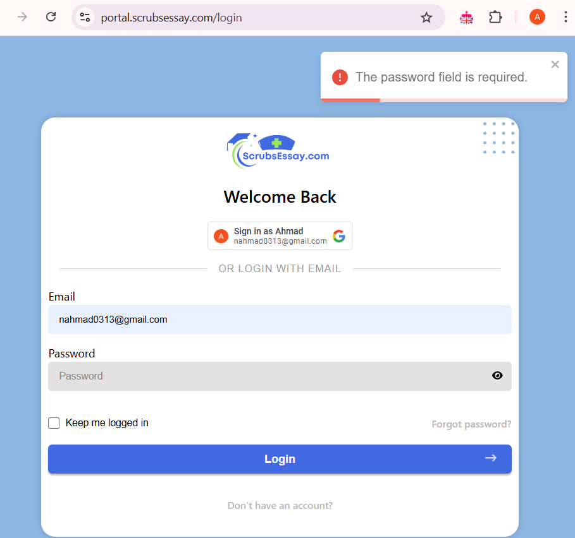

**Status:**

**OPEN**

## ID: UI_02

**Steps to Reproduce:**

1. Navigate to the “Forgot Password” page.
2. Enter email.
3. Go to the inbox.
4. Click “Reset my Password” and navigate to the “Reset Password” page.
5. Fill in the password fields and click the “Reset Password” button.
6. The button’s text alignment deforms when the loader icon appears.

**Status:**

**OPEN**

## ID: UI_03

**Steps to Reproduce:**

1. Navigate to a sign-up page.
2. Hover over the Login Button, beside the text, “Already have an account?”.
3. The login button misaligns.

**Same is the case for Sign-Up Button.**

**Screenshot:**

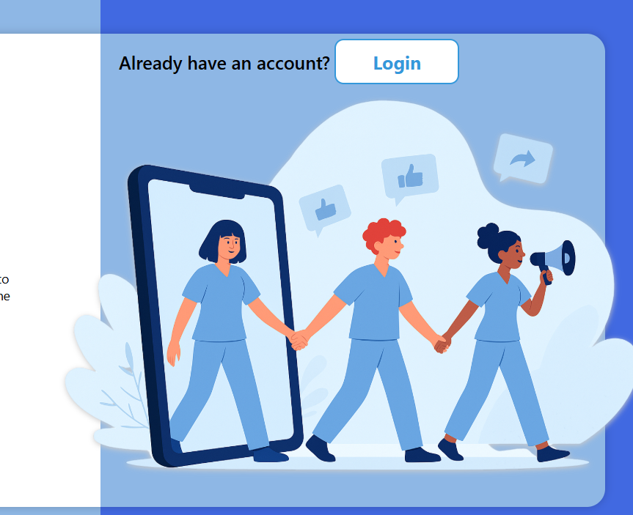

**Status:**

**OPEN**

## ID: UI_04

**Description:**

1. Navigate to the Portal’s “Dashboard” page.
2. In the left panel, the “Complete” button’s label should be “Completed”, to indicate the order status as completed.
3. Also, the color of the header bar of the “Order Chat” window in the left panel is inconsistent to the rest of UI.

The “Order Chat” window shall not appear until user has placed order.

**Screenshot:**

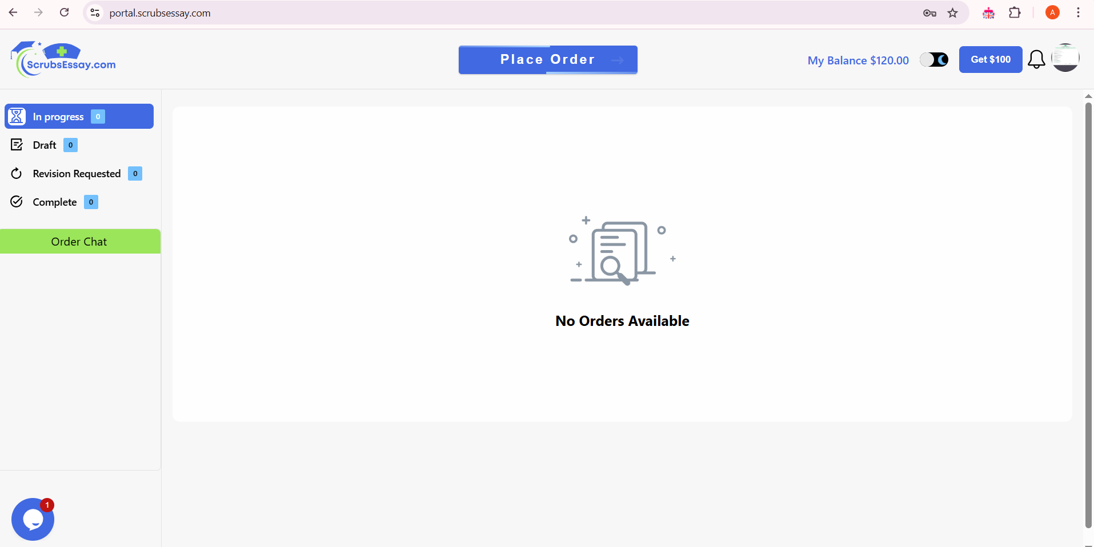

**Status:**

**OPEN**

## ID: UI_05

**Description:**

**Steps to Reproduce:**

1. Navigate to the portal’s Dashboard.
2. The color of the div for the orders’ table – displaying “No Orders Available” - in either of the categories -“In progress”, “Draft”, “Complete” – is not matched with the rest of the portal’s background color.

**Screenshot:**



**Status:**

**OPEN**

## ID: UI_06

### ****Description:****

**Steps to Reproduce:**

1. Navigate to the wallet page.
2. Notice that the “Wallet Transaction” section displays an empty table, which visually seems incomplete.
3. Suggestion: There should be a message like, “**No wallet transactions yet.”**

**Status:**

**OPEN**

## ID: UI_07

Description**:**

**Steps to Reproduce:**

1. Navigate to the wallet page.
2. The first div displaying “User Wallet” Overlaps the “My Balance” div when scrolled down.

**Screenshot:**

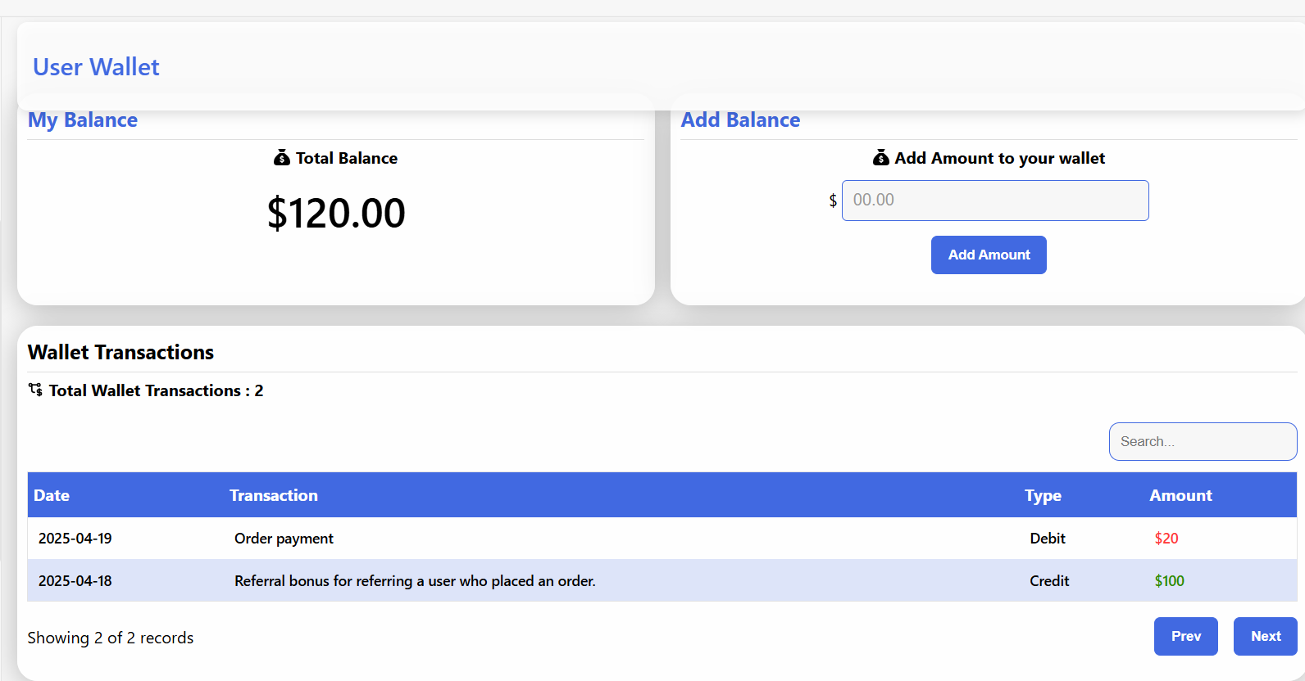

**Status:**

**OPEN**

## ID: UI_08

**Description:**

**Steps to Reproduce:**

1. Navigate to the referral page.
2. The referral link is clickable and redirects to a sign-up page.
3. The problem here is that the user can easily use any other email for the referral bonus and get the orders done for no cost.

Suggestion: It should not be clickable, so that the user cannot find the loophole so easily.

**Screenshot:**

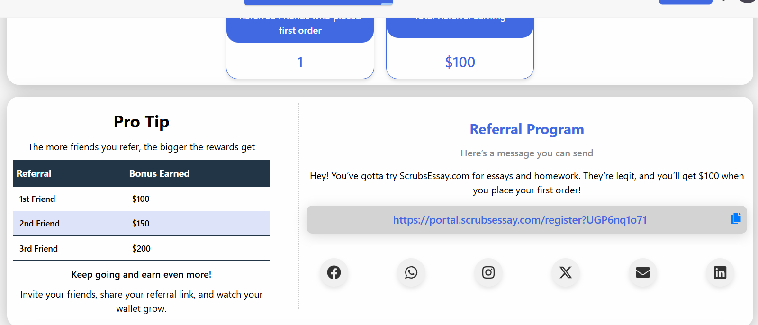

**Status:**

**OPEN**

## ID: UI_09

**Description:**

**Steps to Reproduce:**

1. Navigate to the referral page.
2. This “Pro Tip”, the table’s header row color is mismatched to the rest of the portal’s theme.

**Screenshot:**



**Status:**

**OPEN**

## ID: UI_10

**Description:**

**Steps to Reproduce:**

1. Navigate to the **Profile** page.
2. Click **Edit Profile**.
3. In the photo upload section, click the upload button.
4. You’ll notice:
   1. The system allows selection of **any file type** (e.g., PDFs, DOCs, ZIPs, MP4s).
   2. While there's a **validation check on "Save Profile"**, the file selection dialog itself allows invalid formats.
5. Suggestion: Ideally, the OS file browser should filter for **images only** when opened.
6. **Also, the “Save” and “Cancel” buttons are not properly aligned, which disrupts the UI consistency.**

**Screenshot:**

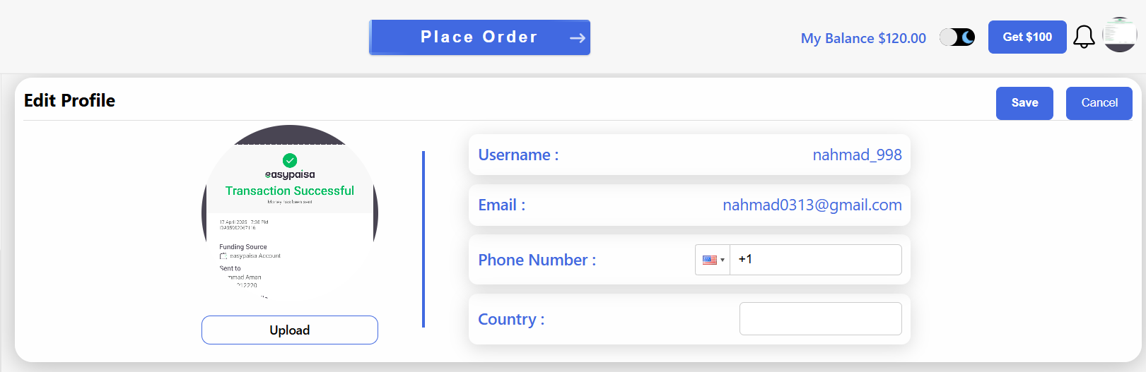

**Status:**

**OPEN**

## ID: UI_11

**Description:**

1. **Navigate to forgot password page.**
2. **Submit email.**
3. **Click “Reset Password” button, in the email received.**
4. **This redirects to reset password page.**
5. **This message, “We have sent a link to,** [abcd1234@gmail.com](mailto:abcd1234@gmail.com)**, is useless.**

**Screenshot:**

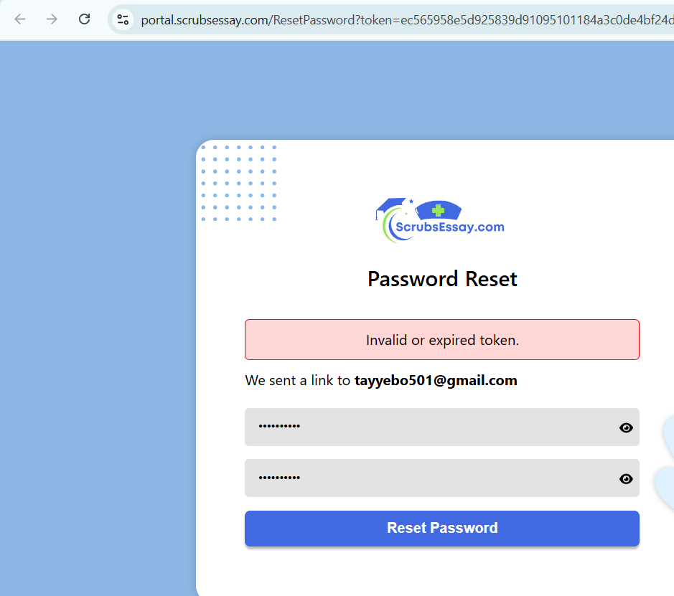

## ID: UI_12:

**Notification window appearance.**

1. **Click the notification icon.**
2. **A notification window appears.**
3. **Now, click the “See all Notifications” button.**
4. **It redirects to the notification page.**

**However, the notification window does not disappear.**

## ****ID: UI_13:****

The logo is not displayed in either of the emails received by the user.